ASSIGNMENT : 4
Q1.In AWS, create a new security group named InstaClone-SG and configure it to allow incoming HTTP (port 80) and HTTPS (port 443) traffic only from your own IP address.
Ans:
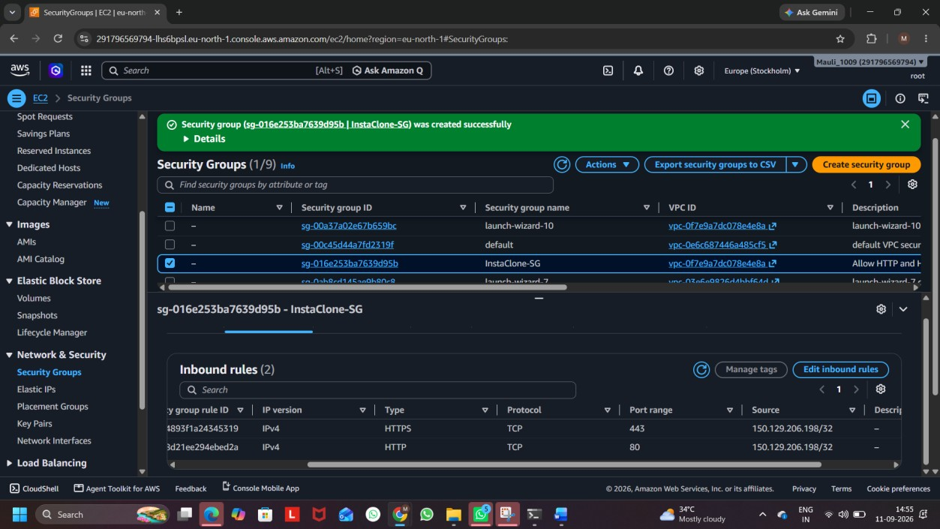

Screenshot: InstaClone-SG Inbound Rules
Created a new AWS Security Group named InstaClone-SG and configured inbound rules to allow HTTP (port 80) and HTTPS (port 443) traffic only from My IP address.

Q2.Set up a security group for a mock Zomato-style backend server that allows incoming MySQL (port 3306) connections only from a specific IP address and blocks all other inbound traffic. Hint: Use the 'Custom TCP' rule and specify the allowed IP in CIDR format.
Ans:
Created a security group named Zomato-Backend-SG and added a Custom TCP rule for MySQL port 3306. The rule allows connections only from the specified IP address in CIDR format (/32).
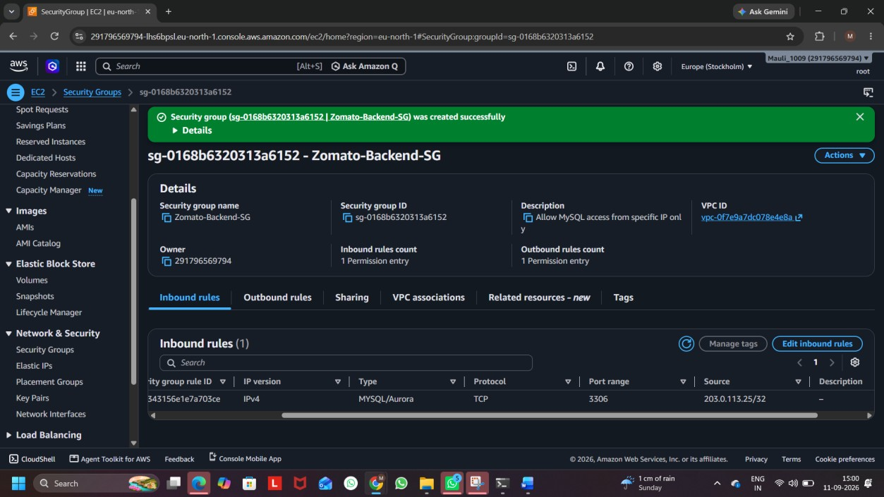

Screenshot: Zomato-Backend-SG Inbound Rules

Q3.Modify an existing security group to block all outbound traffic except for DNS (port 53) and HTTPS (port 443) to simulate a strict Paytm wallet server environment.
Ans:
Modified the existing security group by removing the default All Traffic outbound rule. Added outbound rules for DNS (port 53) and HTTPS (port 443) only.
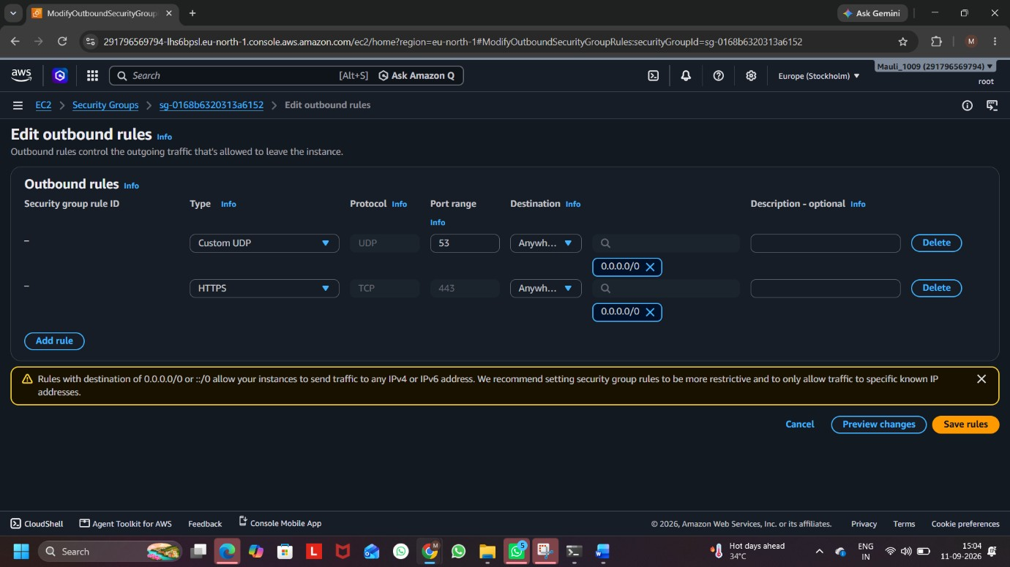

Screenshot: Paytm Security Group Outbound Rules
Q4.Compare security groups and network ACLs by listing two key differences in how they control traffic for a Flipkart-like cloud application.Hint: Think about the level (instance vs subnet) and direction (inbound/outbound) each operates at.
Ans:
Security Groups | Network ACLs
1. Security Groups work at the instance level. They control traffic going to and from a specific EC2 instance. | 1. Network ACLs work at the subnet level. They control traffic for all resources inside a subnet.
2. Security Groups are stateful and control inbound and outbound traffic. If an inbound request is allowed, the response is automatically allowed. | 2. Network ACLs are stateless and have separate rules for inbound and outbound traffic.

Example for Flipkart:
For a Flipkart-like application, a Security Group can protect a particular web server, while a Network ACL can provide an additional traffic-control layer for the entire subnet.

